Department of Veterans Affairs

VistAWeb (NVW) Version 16



Production Installation Guide

Department of Veterans Affairs
Office of Information and Technology
Product Development

Revision History
Date | Version | Description | Authors
12/19/2011 | 0.01 | Initial Draft | Doug Larsen
1/31/2012 | 0.02 | Technical Review | Dena Lebo, Tim Geffre, Gary Tomlinson
2/29/2012 | 1.0 | Released to AITC | Doug Larsen
2/29/2012 | 1.01 | Edited to meet AITC specification | Doug Larsen
3/1/2012 | 1.02 | Removed SQL scripts | Doug Larsen
3/1/2012 | 1.03 | Reviewed and updated with AITC | Doug Larsen
3/6/2010 | 1.04 | Changed for AITC Install | Doug Larsen
3/12/2012 | 1.05 | Post Installation changes | Doug Larsen
04/28/2012 | 1.06 | TWR 1. | Nick Metrokotsas, Technical Writer.
05/29/2012 | 1.07 | Changes made from the NVW V16 Pre-Prod Release | Terri Rose
5/29/2012 | 1.08 | Updates from NVW V16 Pre-Prod Release | Steve Monson
07/10/2012 | 1.09 | Updates to file names, and script parameters for production. | Steve Monson

Table of Contents
1 VistAWeb Production Environment 1
2 Installation Considerations 1
2.1 Backing up the System 2
2.2 Retrieving Files from Staging Location 2
2.2.1 Application Staging Area 2
3 Installing the VistAWeb Software on the Web Server 2
3.1 Technical Background 3
3.2 Gathering Required Information 4
3.3 VistAWeb Web Server Software Installation Detailed Steps 6
3.3.1 Step 1: Retrieve the VistAWeb Release Package 6
3.3.2 Step 2: Unpack the Scripts 9
3.3.3 Step 3: Set Up the Powershell Execution Environment 13
3.3.4 Step 4: Run the VistAWeb Delete Script 14
3.3.5 Step 5: Run the VistAWeb install Script (with parameters) 14
3.4 Installing VistAWeb Using a Pre-completed Command File 16
4 Backout Plan 17
Appendix A 18
Script for Prod installation 18

List of Tables
Table 1: VistAWeb Production Environment Virtual Machines 1
Table 2: Staging Information for the Application Server (VAAUSNVWWEB200) 2
Table 3: Parameters Required by the VistAWeb Install Script 5

List of Figures
Figure 1: Creating a New Folder for the Downloaded Release Package 6
Figure 2: Specifying the Location for Saving the Release Package 7
Figure 3: Specifying the Location for the Release Package (continued) 8
Figure 4: Downloaded Release Package in the Previously Prepared Location 9
Figure 5: Opening the VistAWeb Installation ZIP File 10
Figure 6: Extracting the VistAWeb Installation ZIP File 11
Figure 7: Extracting the VistAWeb Installation ZIP File (continued) 12
Figure 8: Directory Tree Created by Extracting the VistAWeb Installation ZIP File 13
Figure 9: Correct PowerShell Command Execution Environment 14

VistAWeb Production Environment
This section provides VistAWeb system component information for the Production environment, normally referred to as Prod.
The Prod environment is deployed on the Virtual Machines (VMs) listed in Table 1 below. These VMs are hosted on the existing AITC VM Farm.
IMPORTANT NOTE: For the Austin Production Environment only the Web Server: VAAUSNVWWEB200 (Windows) and the Database Server: VAAUSNVWSQL200 (Windows) will be used.
Table 1: VistAWeb Production Environment Virtual Machines
Name of VM | Server features on the VM
Web Server:  VAAUSNVWWEB200 (Windows)  VAAUSNVWWEB201 (Windows)  VAAUSNVWWEB202 (Windows) | Operating System: Microsoft Windows Server 2008 (b4-bit)  VAAUSNVWWEB200 (Windows) has 12GB memory / VAAUSNVWWEB201 (Windows) and VAAUSNVWWEB202 (Windows) have 8GB Memory  4 vCPUs, 40G OS drive  App /Data drive size: D(App)=20G  Web Server: Microsoft IIS Version 7.5  Microsoft DotNet Framework Version 2.0.50727
Database Servers:  VAAUSNVWSQL200 (Windows)  VAAUSNVWSQL201 (Windows) | Operating System: Microsoft Windows Server 2008 (64-bt)  64 bit, 8GB Memory, 2 vCPUs, C:30GB (includes OS and MS SQL Binaries) OS drive  Drive 0 40 gb OS Drive 1 50 gb app Drive 2 10 gb sql logs Drive 3 50 gb backup Drive 4 10 gb tempdb  Microsoft DotNet Framework Version 2.0.50727  Microsoft SQL Server 2008

Installation Considerations
Before actual code can be deployed into the Production environment, you must perform necessary backups of the system and verify that the required files have been dropped into their respective staging areas by the NwHIN VistaWeb Development Team.

Backing up the System
Before the Installation of the SQL database and the VistaWeb application request a snapshot be taken for purpose of being able to restore the Servers to their original configuration before you began the install.

Retrieving Files from Staging Location
The various files associated with the new Adapter code must first be dropped by the NwHIN VistaWeb Development team into two staging areas.
<APP_STAGE> | Location of the VistAWeb installation zip file.

Application Staging Area
The NwHIN VistaWeb Development team drops files for the VAAUSNVWWEB200 server here:
\\Vadevmul01\nhin\NHIN-Staging\NVW\PROD\APP
From this location, you will retrieve the files from the <APP_STAGE> folder.
Table 2: Staging Information for the Application Server (VAAUSNVWWEB200)
Staging Folder Alias | New Files to Install
<APP_STAGE> | - Vistaweb_COMPLETE_16.0.0.T7.7.06.2012.zip  - vhasites_prod_2012-07-06.xml

Installing the VistAWeb Software on the Web Server
Once the Operating System and the HTTP server are in place on the Web Servers, the next task is to install the VistAWeb software. VistAWeb (like all ASP.NET applications) runs as an extension of IIS. The VistAWeb installation creates web sites under the control of IIS and web applications within those web sites. It also creates applications pools for the applications within a web site to use. For the relationship between web sites, web applications, and application pools in IIS Version 7 see (for example)
“Understanding Sites, Applications, and Virtual Directories on IIS 7” at the URL http://learn.iis.net/page.aspx/150/understanding-sites-applications-and-virtual-directories-on-iis/.
As of Version 16, the VistAWeb installation procedure has been modified to create the required sites, application pools, and web applications using a PowerShell script. This means that once the base builds have been created and verified, installing VistAWeb proper is accomplished by running a single install script and supplying the appropriate parameters. Most of the time required to perform an installation is spent in gathering the information required to set the parameter values correctly. The install script itself takes only a few minutes to run.
The number of web sites and web applications that are created by running the install script depends on the nature of the installation as explained in the next section.

Technical Background
When a single VistAWeb instance is installed on a single server, three web sites are created and one application (the root application) is created for each site. Each site has one or two application pools so the structure created on IIS in this case is as follows:
- “vw” web site (“vw” app pool)
  - “vw” web app*
- “vwContext” web site (“vwContext” app pool)
  - “vwContext” web app*
- “vwMeans” web site (“vw_default” app pool)
  - “vwEncrypt” web app (“vwEncrypt” app pool)
*= The server won’t show the web app name because it is integrated into the web site.

The reason the “vwMeans” web site contains an app with a different name, is because “vwMeans” is reserved to host more internal VistaWeb services in the future. You’ll also note that there are four application pools for the arrangement above. This is because web application subordinates of “vwMeans” (in this case vwWencrypt) need their own respective application pools.
Since ASP.net applications can run side-by-side on the same server (even with different .Net frameworks), the VistAWeb install scripts are designed to create any number of VistAWeb instances on a single server. If multiple instances of VistAWeb are hosted on one server (different test versions, for example), each one of these instances is called a “named instance” of VistAWeb on the server. The name of the instance is used as a sort of name spacing convention for setting up the web applications and their application pools. In other words, the instance name is used as part of a naming convention which keeps the web applications and their application pools from colliding.
Here’s an example of how the preprod instance of VistAWeb could be setup on a server.
- “vw” web site (“vw_default” app pool)
  - “preprod” web app (“vw_preprod” app pool)
- “vwContext” web site (“vw_default” app pool)
  - “preprod” web app (“vwContext_preprod” app pool)
- “vwMeans” web site (“vw_default” app pool)
  - “preprod” virtual directory
    - “vwEncrypt” web app (“vwEncrypt_preprod” app pool)
The VistAWeb install scripts can set up a single instance VistAWeb environment, or an environment containing multiple named VistAWeb instances.

Gathering Required Information
NOTE: It is much easier in practice to create an environment installation script which calls Install-<instance name>.ps1 with all of the command line parameters preset to the correct values. This avoids having to type them in on the command line in real time, which is tedious and error-prone. Details on preparing and executing such an environmental install script will be presented in the next section. Whichever method is chosen, information will need to be gathered to complete the following table prior to install.

Current versions of VistAWeb are installed into IIS using a PowerShell script:
- Install-VistAWeb.ps1
This script takes a number of parameters and it is necessary to provide them in a timely fashion (or the script will time out). The best way to do this is to learn the required values ahead of time and complete the following table:
Table 3: Parameters Required by the VistAWeb Install Script
Parameter | Value
Script Parameters Entered on the Command Line
-zipFile | Vistaweb_COMPLETE_16.0.0.T7.7.06.2012.zip
-installTargetRoot | D:\data\vwinstall
-sitesFile | vhasites_prod_2012-07-06.xml
-testInstance | N
-db_server | VAAUSNVWSQL200
-db_name | EMR
-db_userId | (created when the SQL database Create and Grant Application User to Role VW_APPLICATION script was installed sec. 4.3.3)
-vistaSecPhrase | SEMPER FIDELIS (Note; this parameter is case sensitive)
-awivSecPhrase | VISTA IMAGING AWIV (Note; this parameter is case sensitive)
-showVersion | N
Parameters Entered When the Script Runs
vw IP address | 10.224.81.236
Site name for host header | Should be left blank
Vw certificate number | Select certificate associated to “vistaweb.med.va.gov”
vwContext port number | 19985
vwContext IP address | 10.224.81.237
vwMeans port number | 18988
vwMeans IP address | 10.224.81.238
“Create a single installation of VistaWeb? (Enter 'Y' to continue)” | Type Y and press <enter> when this prompt appears.
“Enter the database user password?” | Type in the database user password and press <enter> (the screen will show *’s when the password is entered)

VistAWeb Web Server Software Installation Detailed Steps

Step 1: Retrieve the VistAWeb Release Package
- Log in to the server where VistAWeb will be installed.
- Create the directory D:\data\vwinstall on the D:(APP) drive. This will be the working folder for the installation of the VistAWeb Application.
Figure 1: Creating a New Folder for the Downloaded Release Package
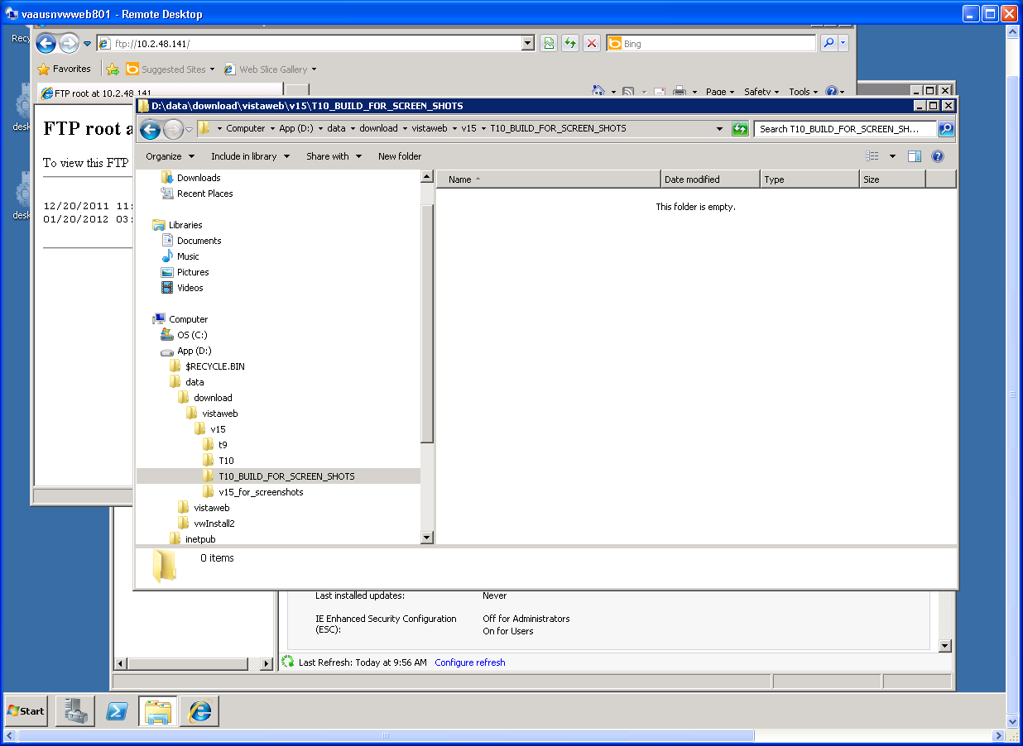

- Retrieve the complete release package ZIP from the VistAWeb database staging area.
\\Vadevmul01\nhin\NHIN-Staging\NVW\PROD\APP

You will be prompted for a download location as shown in the following figure:
Figure 2: Specifying the Location for Saving the Release Package
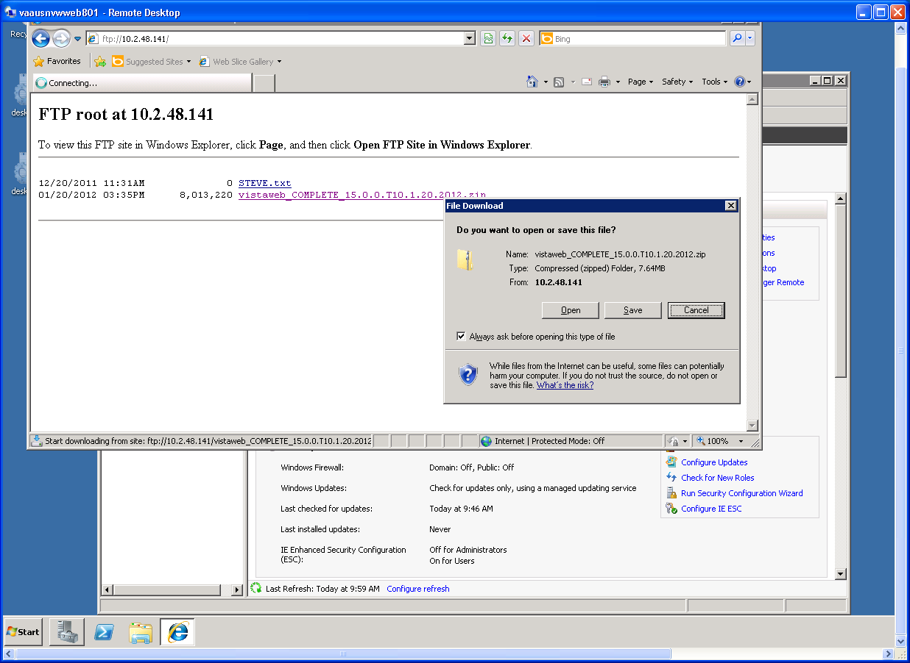

- Click the Save button to specify a location for the downloaded file.
- Browse to the location you created previously for holding the downloaded release package.
An example is shown in the following figure.
Figure 3: Specifying the Location for the Release Package (continued)
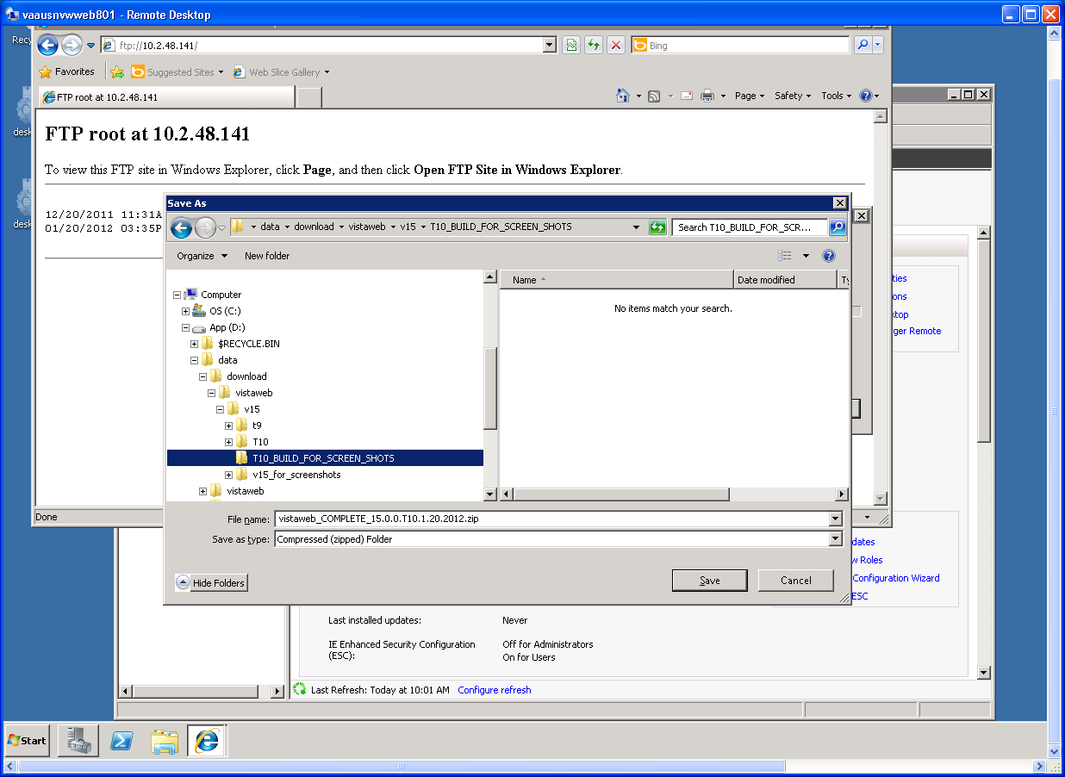

- Click OK to dismiss the File Save dialog.
The file will be downloaded into the location you selected.
The following figure shows the release package saved in the directory that was created previously.
Figure 4: Downloaded Release Package in the Previously Prepared Location
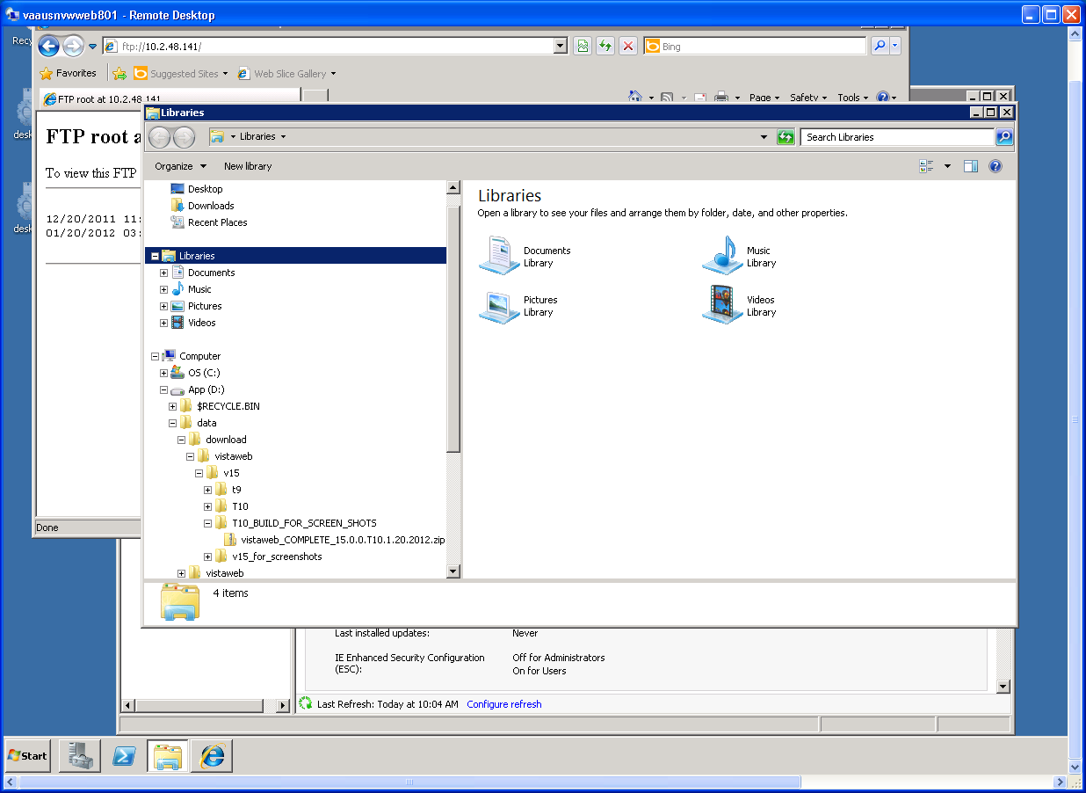

Step 2: Unpack the Scripts
- View the content of the vistaweb_COMPLETE_16.n.n.tn.mm.dd.yyyy.zip ZIP file by clicking on it.
A screen shot of how to open the file is shown in the following figure:
Figure 5: Opening the VistAWeb Installation ZIP File
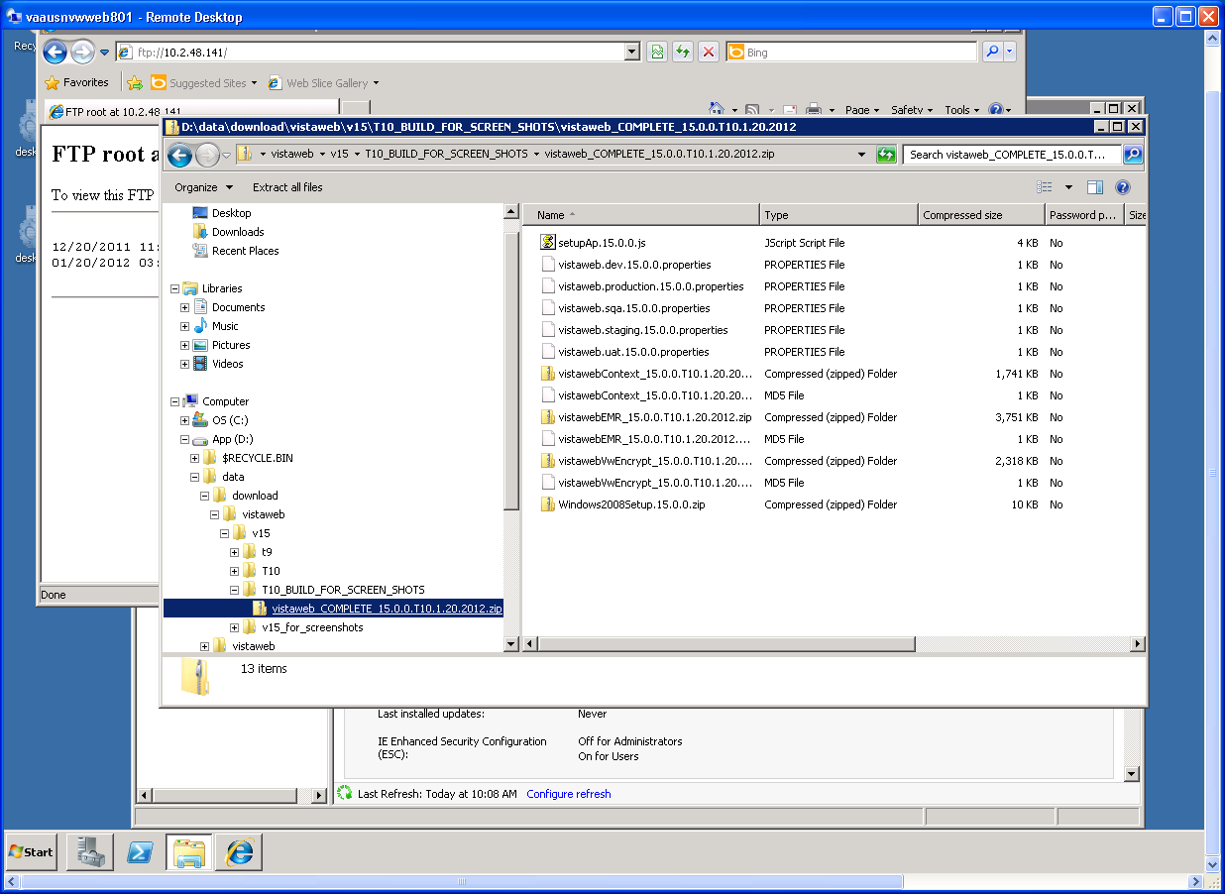

- Highlight the ZIP file called Windows2008Setup.16.n.n.zip and extract it into in the current directory.
- Open the Windows2008Setup.16.n.n.zip ZIP file and extract the script files in the current directory.
The following two figures show how to do this.
Figure 6: Extracting the VistAWeb Installation ZIP File
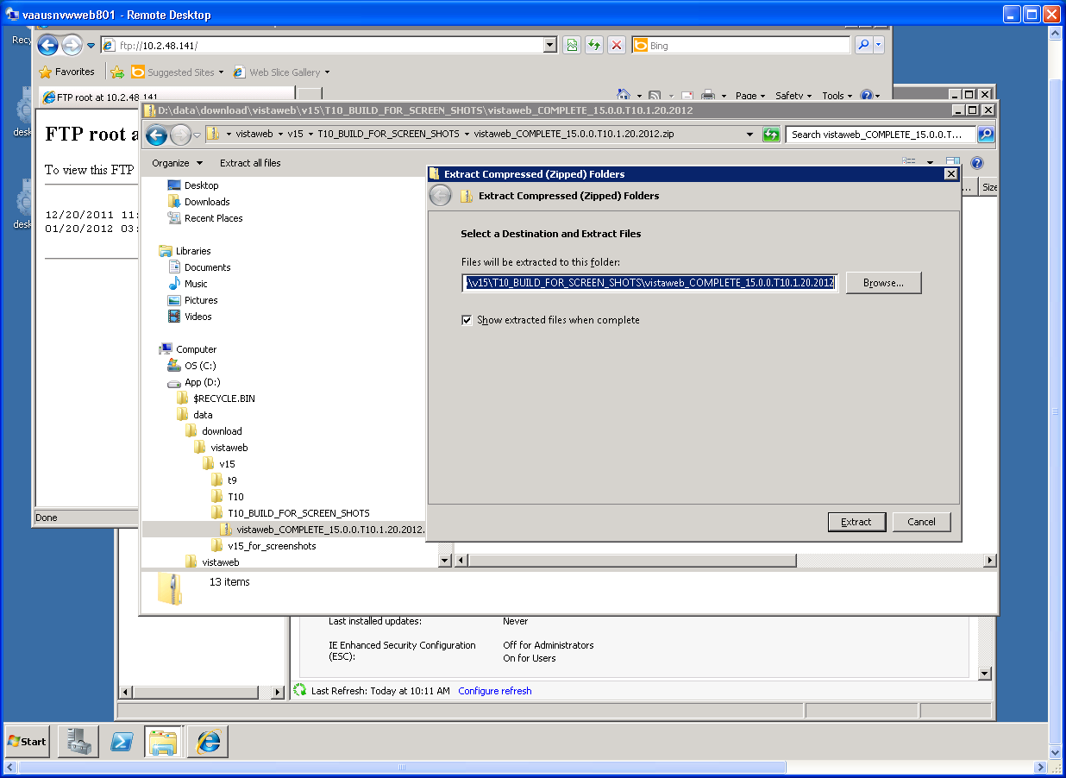
Figure 7: Extracting the VistAWeb Installation ZIP File (continued)
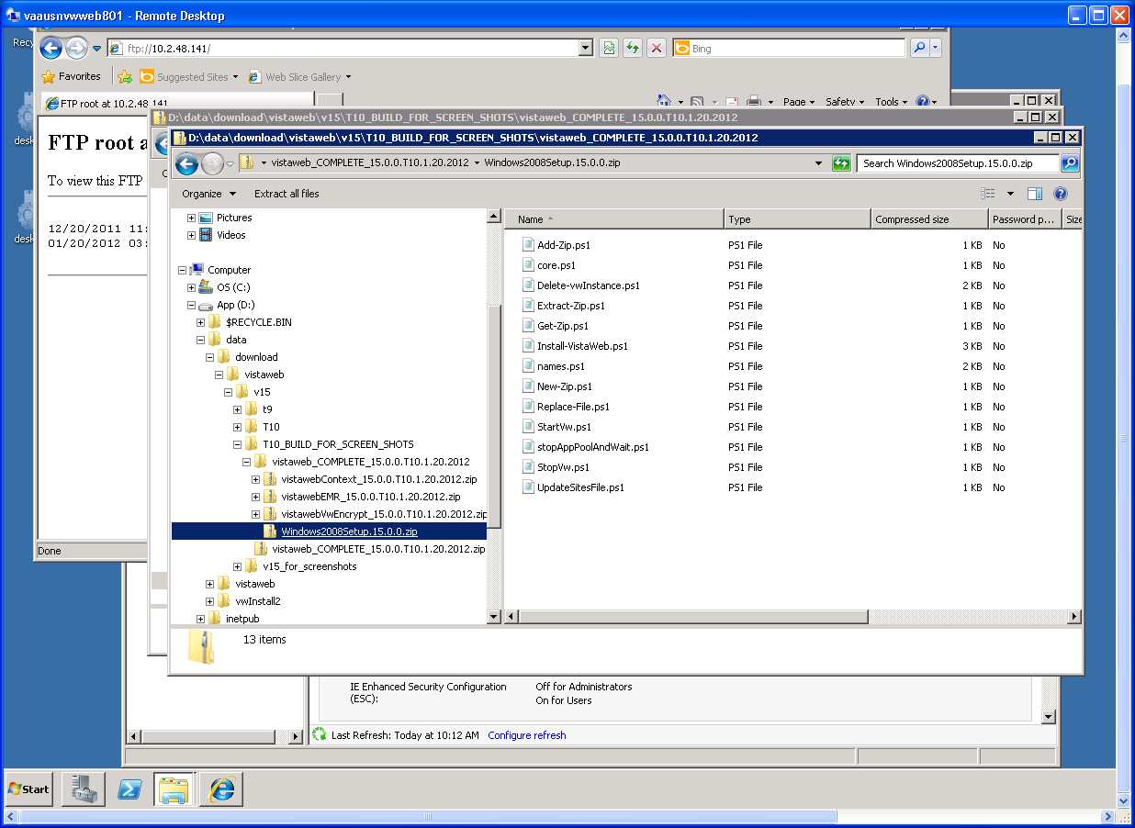

The following figure shows the directory tree created when the zipfile is extracted.
Figure 8: Directory Tree Created by Extracting the VistAWeb Installation ZIP File
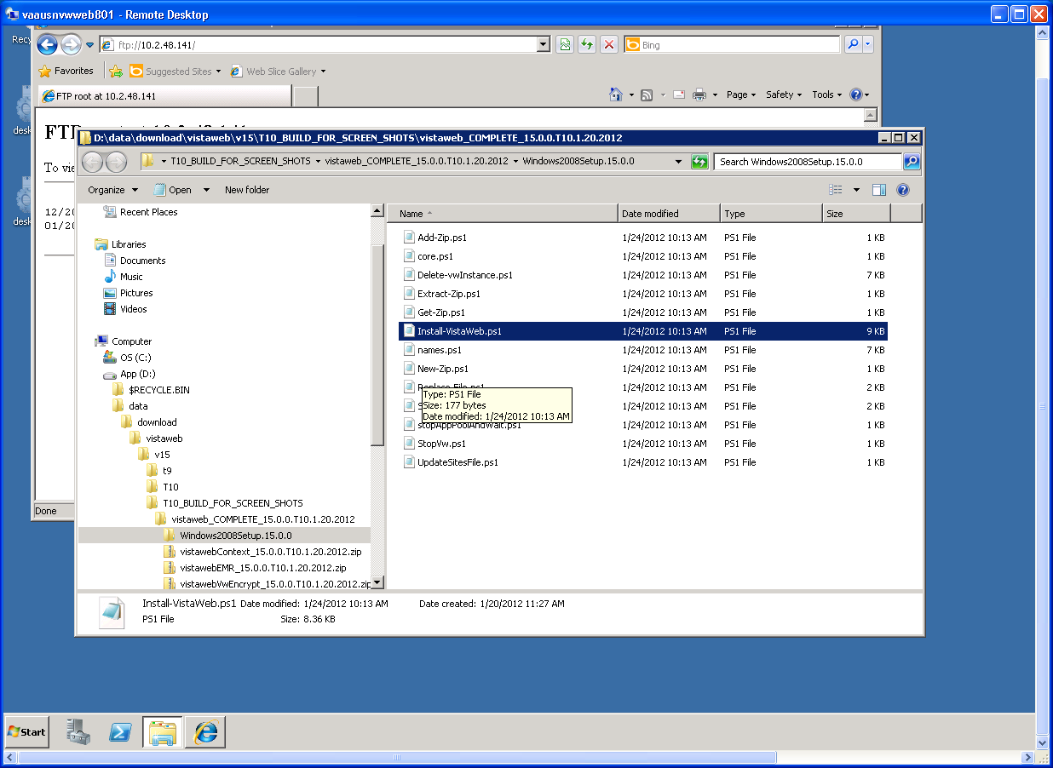

Step 3: Set Up the Powershell Execution Environment
- Start up the Powershell command shell by clicking on the blue icon on the Task bar.
It is in the lower left corner of the window next to the start button.
NOTE: The following step is Important to provide you permissions to execute commands within the PowerShell Environment.
- Execute the command “Set-Location <path>” where the <path> is the location that the script files were extracted in step 2: Unpack the scripts.
For example, “Set-Location d:\data\download\vistaweb\v16\t7\ vistaweb_COMPLETE_16.0.0.t7.7.06.2012.zip\ windows2008setup.16.0.0”.
The following figure shows how the powershell command environment looks after the execution environment has been set up correctly.
Figure 9: Correct PowerShell Command Execution Environment
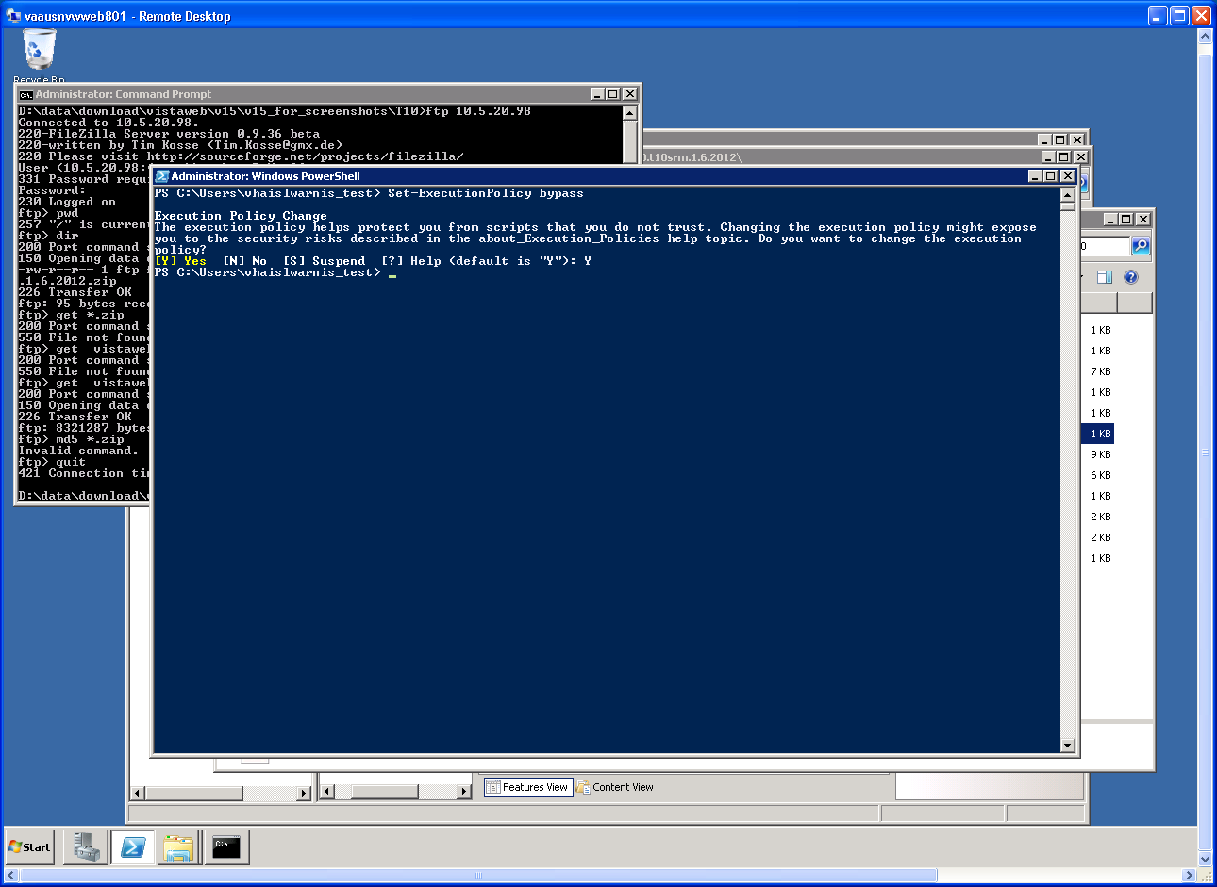

Step 4: Run the VistAWeb Delete Script
The procedure in this section is to remove any prior instances of VistaWeb.
- Open PowerShell
- Change the working directory to the one that the version 16 scripts are stored in.
- Run the script called Delete-vwInstance.ps1 without any parameters.

Step 5: Run the VistAWeb install Script (with parameters)
The procedure in this section asks you to enter each of the parameters required by the install script contained in table 6 at the command line. The use of a pre-completed command file (as described in the next section) eliminates the need to enter parameters in real time at the command line, which is tedious and error prone.
- On the Powershell command line, enter the command “.\InstallVistaWeb.ps1” followed by the given parameters.

Note: Each parameter value should be enclosed in double quotes:

- instanceName – Optional. For NVW v16 Prod, do not use this parameter. For servers which have multiple instances of VistAWeb running, an instance name is given here. This name must be compatible to be used within a URL string (no spaces, no special characters, etc.). If this parameter is not used, when the script is run it will ask you to confirm that you’re installing a single VistAWeb instance on the server.
- zipFile – Required. The name of the vistaweb_COMPLETE_16.n.n.tn.mm.dd.yyyy.zip ZIP file that is to be installed in the VistAWeb instance. It must be specified with an absolute path.
- installTargetRoot – Required. The full path of the folder that the given instance is to be installed in. It does not need to exist before running the script. It is recommended that this is not the same folder created earlier in this set of instructions.
- sitesFile – Required. The path and name (absolute) of the file that will be used as the VhaSites.xml file (the “sites file”) for this instance. CM or Product Support will supply the actual file (see Responsibility Matrix).
- testInstance – Required. Choose “Y” to indicate that this instance will be a production instance.
- db_server – Required. The fully qualified domain name (FQDN) name of the SQL Server that this VistAWeb instance will use. If this parameter is not specified in the command line, the script will ask for this value when it runs.
- db_name – Required. The name of the SQL Server database that this VistAWeb instance will use. If this parameter is not specified in the command line, it will ask for this value when the script runs.
- db_userId – Required. The application user name in the specified database. If this parameter is not specified in the command line, it will ask for this value when the script runs.
- db_userPw – Required. The application user password in the specified database. If this parameter is not specified in the command line, it will ask for this value when the script runs.
- showVersion – Required. Enter a “N” in this field to indicate the instance should show an abbreviated version number.
- vistaSecPhrase – Required. For v16 Prod, use “SEMPER FIDELIS”. The VistA Broker Security Enhancement (BSE) security phrase for VistAWeb (see http://tspr.vista.med.va.gov/warboard/anotebk.asp?proj=994).
- awivSecPhrase – Required. For NVW v16 Prod, use “VISTA IMAGING AWIV”. The BSE security phrase for the AWIV (which runs within VistAWeb on users’ browsers).
NOTE: The parameters can be put on the command line in any order.
- The script will ask other questions when it executes. (Installations for multiple named instances only show these questions for the first installation).
- What IP address should be used for vw ? [Enter nothing for '*']: - The IP address assigned to the user facing portion of VistAWeb (“vw”), it should be entered here (10.224.81.236 for production).
- What site name should be used as the host header for this site? [Can be blank]: - Anywhere this prompt is found, it should be left blank (it will be removed from a future version of the install script).
- select a certificate number to use for vw (1 - n ): - When this prompt displays, it will be followed by a list of certificates assigned to the web server. Enter the number in front of the certificate desired. Select the number corresponding to “vistaweb.med.va.gov”.
- What port should be used for vwContext ?: - Enter the port number assigned to the “vwContext” web instance (19985 for production).
- What IP address should be used for vwContext ? [Enter nothing for '*']: - The IP address assigned to the server for the “vwContext” service should be entered here (10.224.81.237 for production).
- What port should be used for vwMeans ?: - Enter the port number assigned to the “vwMeans” site (18988 for production).
- What IP address should be used for vwMeans ? – The IP address assigned to the server for the “vwMeans” site should be entered here (10.224.81.238 for production).
- For example, to setup a development instance of VistAWeb, one could execute the following command:
.\Install-VistaWeb.ps1 -zipFile "D:\data\download\vistaweb\v16\vwinstall\vistaweb_COMPLETE_16.0.0.t7.7.06.2012.zip" -installTargetRoot "D:\data\vwInstall" -sitesFile "D:\data\download\vistaweb\v16\VhaSites_prod_2012-07-06.xml" -testInstance "N" -db_server "VAAUSNVWSQL200" -db_name "EMR" -db_userId "XXXXXX" -db_userPw "XXXXXX" -showVersion "N" -vistaSecPhrase "SEMPER FIDELIS" -awivSecPhrase "VISTA IMAGING AWIV"

Installing VistAWeb Using a Pre-completed Command File
As mentioned earlier, the easiest way to install the VistAWeb software is to use a pre-completed command file, meaning a command file which invokes the install script with the values of the parameters already entered. We strongly recommend using this procedure in lieu of trying to enter parameters on the command line when executing Install-VistAWeb.ps1. To use a pre-completed command file, proceed as follows:
- Create an empty file called Install-Prod.ps1 in the same folder as the VistAWeb installation scripts. The install scripts can be found in the install package tree at:
…\vistaweb_COMPLETE_16.0.0.T7.7.06.2012\Windows2008Setup.16.0.0
- This will be the master install script for the current install.
All it does is put all of the complicated and error-prone parameters required for the actual install script into one place so you can edit them and get them right ahead of time (before executing the install script) rather than having to edit them correctly on the command line.
- Gather the information specified in section 4.2 and complete table 4 for your target environment.
- Based on the results of your search, enter the command and parameters in the master install script to match your requirements. The file can be edited with Notepad by right-clicking the file icon, selecting Open with and choosing Notepad. See Appendix A for an example of the contents.
- When you are done editing, proceed as follows:
  - Save your master install script. (Make sure to save it into the same directory above where the other install scripts are found.)
  - Start Powershell and set up the Powershell execution environment as per the install guide (4.3.3 Step 3: Set up the Powershell Execution Environment).
  - Execute the master install script (for your environment – the one you just saved with modified parameters) as a Powershell command. For example ./Install-Prod.ps1
  - You will be prompted for the certificate number and the IP address for vwContext. Enter the values you obtained and entered into table 4 on the command line.
  - You will be prompted for the certificate number and the IP address for vwContext. Enter the values you obtained and entered into table 4 on the command line.
- Once the master install script has completed without errors you may verify the installation (i.e., the existence of the right web sites, web applications, and application pools as shown in the Technical Overview section of the manual.)
A Prod installation script is on the application drop site.

Backout Plan
The rollback of the Server to its original configuration before the VistAWeb install can be accomplished in two different methods. If the snapshot is available and untouched you can restore the snapshot back to the original configuration and begin the install again. If this is not available you can also delete the lower directory you created (D:\\data\vwinstall) when you installed the application and begin again. To rollback a snapshot you are constrained to the two week time period that the snapshot is held. This installation is estimated to be complete within a one hour period. If due to unforeseen circumstances this installation takes more than four hours without any progress the AITC Project Manager will be asked to continue the operation or to roll back to the bare metal configuration. Many of the updates and changes that are required for the VistAWeb application are scripted and included with the zip file that is used for the original build. So the current procedure is to use those scripts to modify or change the application and the determining factor to remove the application is usually to change to a new version.

Appendix A
Script for Prod installation

Install-Prod.ps1

.\Install-VistaWeb.ps1 -zipFile "d:\data\download\vistaweb\v16\vistaweb_COMPLETE_16.0.0.T7.7.06.2012.zip" -installTargetRoot "D:\data\vwInstall" -sitesFile "d:\data\download\vistaweb\v16\VhaSites_prod_2012-07-06.xml" -testInstance "N" -db_server "VAAUSNVWSQL200" -db_name "EMR" -showVersion "N" -vistaSecPhrase " SEMPER FIDELIS" -awivSecPhrase "VISTA IMAGING AWIV"

